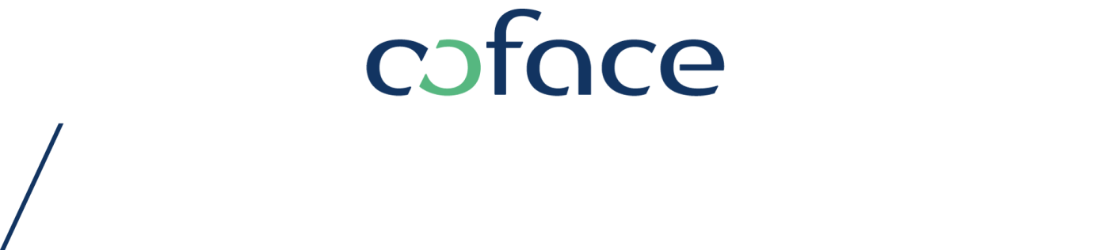

PRESS RELEASE

Vienna / Mainz, 4 March 2016

Risks for German exports have risen significantly

The greater export risks faced by German companies are hampering growth performance. As Germany has strong trading ties with the Emerging Market and Developing Economies group (EMs), it is highly exposed to the structural and cyclical weaknesses within these economies. “These external impacts are currently negative, as growth in exports to EMs has been cooling down and is now much weaker than demand from Advanced Economies”, explained Dr. Mario Jung, Regional Economist for Northern Europe Region at Coface.

German economy faces greater external risks

In 2016, German exports will probably show the same trends as reported in 2015. Growth in exports to Advanced Economies should be solid and robust, whereas export risks are much higher for products with EM destinations. The global risk mixture of political and military conflicts, terrorist attacks and structural challenges in many EMs, as well as China’s weakening GDP growth, are still weighing on the external demand for German products. This downwards pressure on external demand could become even more pronounced.

From a regional perspective, German export companies still remain the most optimistic on future business with Advanced Economies. They foresee the weakest perspectives for this year in South and Central America, Eastern Europe, Russia, Turkey and China. From a sectorial perspective, some of Germany’s key industries are particularly vulnerable to risks stemming from EMs. Coface evaluates the most significant risks as being in the Automotive and Mechanical Engineering sectors, in addition to Electrical Equipment. Further risks from EMs are also materialising in the cyclically-sensitive chemical industry.

Almost 29% of Germany’s total exports are delivered to EMs. Of these exports, more than a fifth are shipped to China, which is equal to 6 % of Germany’s total cross-border deliveries. This share means that Germany is more exposed to external risks stemming from EMs than most other Euro zone countries. On average, EMs’ share of euro-area exports is around
26 %.

“For export-oriented companies, the renewed fall in global oil prices is a matter for concern, since it indicates weak global aggregate demand. Furthermore, growth prospects for many EMs remain subdued. The scenario of a ‘gradual landing’ in China will also have a negative impact on Germany’s export industries”, said Dr. Mario Jung.

The German economy has shifted its growth model during recent years

While internal demand - especially private consumption – was sluggish and weak throughout most of the 2000s, it is currently the most important driver for growth. In contrast, net exports, which have been so important for Germany’s economic development in the past, were relatively neutral in terms of growth performance in 2015. Moreover, net exports are likely to dampen GDP growth this year, due to weaker export development and a strong continued rise in imports. Nevertheless, thanks to the country’s robust internal demand, Coface forecasts GDP growth of 1.7 % for this year.

MEDIA CONTACT
Verena SCHWARZ - T. +43 (0) 1 515 54-540 – verena.schwarz@coface.com

About Coface

The Coface Group, a worldwide leader in credit insurance, offers companies around the globe solutions to protect them against the risk of financial default of their clients, both on the domestic market and for export. In 2015, the Group, supported by its ~4,500 staff, posted a consolidated turnover of €1.490 billion. Present directly or indirectly in 99 countries, it secures transactions of 40,000 companies in more than 200 countries. Each quarter, Coface publishes its assessments of country risk for 160 countries, based on its unique knowledge of companies’ payment behaviour and on the expertise of its 340 underwriters located close to clients and their debtors.
In France, Coface manages export public guarantees on behalf of the French State.
www.coface.com
Coface SA. is listed on Euronext Paris – Compartment A
ISIN: FR0010667147 / Ticker: COFA

